Tender Ai – version 1 -
After discussions ocr+ vlm will be introduced
1. How do you actually detect text vs. scanned vs. table on a page?
This is a cheap, rule-based classifier that runs before any LLM call — no AI needed for this step, just PDF-library metadata. Here's the actual mechanism, using a library like PyMuPDF:
For every page, pull three signals:
- Text layer check: call the library's text extraction on that single page and count characters returned. A real digital page of prose typically returns several hundred to a few thousand characters. If it returns almost nothing (near-zero), the page has no embedded text layer — it's a scanned image, full stop.
- Image coverage check: the PDF library also tells you what images are embedded on a page, with their bounding boxes. If there's one image whose area covers nearly the entire page and the text-layer check came back empty, that confirms scanned page — the "text" you'd see if you looked at it is actually baked into a picture.
- Layout/structure check for tables: this is different from the yes/no text check — it's about shape. Pull word-level positions (each word's x/y coordinates, not just raw text). If many consecutive lines have words starting at the same repeated x-positions (columns lining up vertically), that's a strong table signal — that's literally what a table is: repeated column alignment. Dedicated table-detection libraries (e.g. pdfplumber's table extraction, camelot) use exactly this — line/ruling detection for bordered tables, whitespace-clustering for borderless ones.
Combine the three signals into one classification per page, stored as simple metadata: {page_number, char_count, image_area_ratio, has_column_alignment, classification} where classification is one of native_text, scanned_image, table, or mixed. This whole check runs in milliseconds per page and costs nothing — it's just parsing PDF internals, not calling any model.

2. Deduplication — the mechanism, and why "similar headers" isn't enough
You're right to push on this — format similarity is not content similarity, and using it as your dedup signal would be a real bug: two GCC pages can look visually identical (same header, same template) while the actual clause text underneath differs — different LD percentage, different EMD amount, different date. So the dedup key can never be "this looks like a standard page." It has to be exact content.
The mechanism:
- Take the extracted text of a page (not the image, not the layout — the actual words).
- Normalize it lightly (lowercase, collapse whitespace) so formatting noise doesn't cause false mismatches.
- Run it through a hash function (SHA-256) to get a fixed-length fingerprint.
- Store that fingerprint alongside the already-extracted result in a small reference table — think of it as a "known clauses" library, keyed by hash, tagged with which issuing authority it came from.
- Next time you're about to parse a page: compute its hash first, check if that exact hash already exists in the library. If yes — reuse the stored result, skip extraction entirely. If no — even one different word (a different date, a different amount) produces a completely different hash, so it gets extracted fresh, exactly as it should.
This is precisely why hashing the text content rather than the template/layout solves your concern automatically: a page that looks the same but has one different number in it will never falsely match, because the hash is computed after extraction, over the actual words. Two truly identical boilerplate pages (no tender-specific data inserted at all) get the same hash and correctly get skipped.
(A more advanced version of this — fuzzy/near-duplicate matching using something like MinHash — exists for catching pages that are almost identical but not byte-for-byte, e.g. minor OCR noise on two scans of the same standard page. Worth adding later; exact hashing alone gets you most of the win with far less complexity to start.)
On "local system or file directories" for images — don't, in production. Local disk storage means: it's tied to one server, it doesn't survive that server restarting or being replaced, it can't be accessed by multiple parallel worker processes doing extraction at once, and you have no built-in redundancy if a disk fails. The standard production answer is cloud object storage (AWS S3, or a compatible alternative like Cloudflare R2) — each page image gets a path like tenders/{document_id}/pages/{page_number}.png, and your database just stores that path as a pointer, not the image itself. This is exactly what lets you scale to many documents processing in parallel without a single machine becoming a bottleneck or single point of failure.

3. Why a cheap-model first pass at all?
Because extraction and judgment are different kinds of work, and paying premium-model prices for the first one is wasted money.
- The first pass's job is mechanical: "find every date in this text, find every number that looks like a penalty rate, find the page number this appeared on." That's closer to pattern-matching than reasoning — a smaller, faster, cheaper model does this reliably.
- The second pass's job is judgment: "given all these extracted clauses together, how severe is this risk, does it conflict with another clause, should this tender even be pursued." That genuinely benefits from a stronger model's reasoning — and by this point, it's reading a short distilled summary, not the raw document, so you're not paying the expensive model's rate against hundreds of pages.
- This also shrinks what the expensive model has to read. Without the first pass, your best model would need the entire raw document in its context to do the final scoring. With it, that same model reads a few thousand words of already-extracted facts — cheaper per call, and also avoids feeding it the kind of huge raw context where the lost-in-the-middle problem creeps back in.
This is a standard cost pattern: cheap model for retrieval/extraction-style work, expensive model reserved for the step that actually needs judgment.

4. Full storage architecture, in depth
Here's the layered structure — this follows what's often called a bronze/silver/gold pattern, and the separation matters because each layer has a different job, a different cost to regenerate, and a different access pattern.
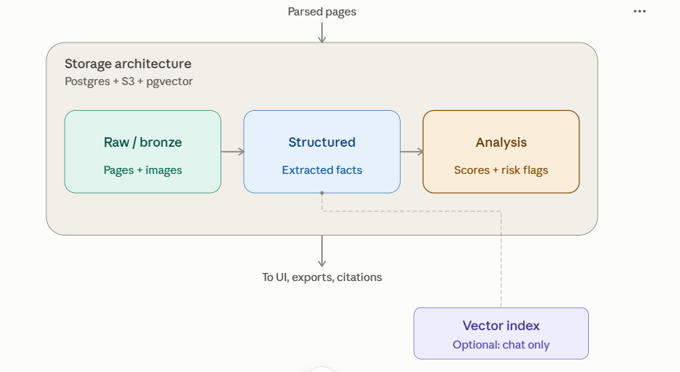

What lives in each layer, concretely
Raw / bronze layer — the ground truth, never modified after first parse.
- A documents record per tender: id, filename, issuing authority, total pages, upload time.
- A pages record per page: page number, its classification (from step 1), the extracted raw text, a pointer (S3 path) to the page image, the content hash (from step 2), and a confidence score.
- Tables get their own record: the row/column data stored as structured JSON, linked back to the page it came from.
- This layer is your audit trail. Every claim your AI ever makes has to be traceable back to a specific row here.
Structured / silver layer — the compact, curated output of the cheap-model extraction pass.
- One record per chunk: which page range it covers, and a structured JSON blob of what was pulled out — dates, financial figures, eligibility criteria, candidate risk clauses, each one tagged with the page number it came from.
- This is derived data — if something goes wrong with it, you can regenerate it from the raw layer without re-running the expensive parsing step. That's the whole point of keeping it separate: raw parsing is expensive to redo, this distillation step is comparatively cheap to rerun.
Analysis / gold layer — the final, expensive-model output.
- One record per tender per module (Go/No-Go, Synopsis, Risk Finder): the actual score, the summary text, the ranked risk list — this is what the UI reads and what gets exported as a report.
- Also derived — regenerable from the structured layer if you improve your prompts later, without touching the raw pages at all.

How retrieval actually works, per use case
- Displaying the final analysis to a user: direct lookup in the analysis layer by document_id + module name. No search, no LLM call — it's already computed and sitting there.
- Verifying a flagged risk's citation: direct lookup in the raw layer by document_id + page_number. Fast, indexed, exact — you're not searching for the page, you already know exactly which one it is because the structured layer told you.
- Re-running analysis after a prompt improvement: pull everything from the structured layer for that document, feed it to the new reduce prompt, write a new analysis-layer record. Raw parsing is never touched.
- A "chat with this tender" feature (if you build one later): this is the only place the vector index gets used. Embed the user's question, search the vector index for the most relevant chunks, then pull the actual text for those chunks from the raw layer to build the answer. This index is populated separately, off to the side — it's not in the main Go/No-Go/Synopsis/Risk-Finder path at all, exactly because those modules need full coverage, not top-k relevance (as we covered a couple turns back).
The separation is what makes this maintainable: each layer answers to a different failure mode — bad parsing means fix the raw layer, bad extraction means regenerate the structured layer cheaply, bad judgment means regenerate the analysis layer without touching anything upstream. You never have to re-pay the most expensive cost (parsing 1000 pages) just because you tweaked how the final risk score gets calculated.
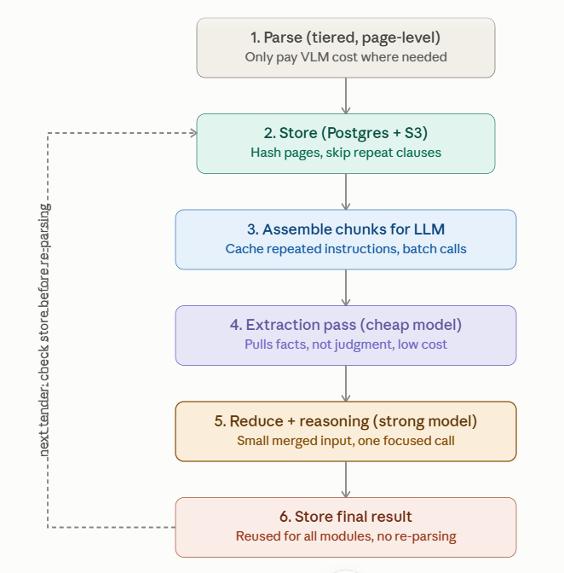

In simple words, stage by stage, and how each one keeps the bill down:
1. Parse — read every page, but only pay full price when you have to.
A quick, near-free check tells you whether a page is clean digital text (extract for free) or scanned/table (needs the paid vision path). In a typical tender, most pages are plain text — you're only sending the messy minority to the expensive extractor, not all 1000 pages.
2. Store — save it so you never parse the same thing twice.
Text and table data go into a database (Postgres). Original page images go into cheap object storage (S3), just as a reference in case a human needs to double-check something. Every page also gets a small fingerprint (a hash). Government tenders from the same authority reuse a lot of boilerplate (same GCC, same standard clauses) — if you've already parsed that exact page before, you skip it entirely next time instead of paying to re-read it.
3. Assemble for the LLM — group pages into small batches, and reuse the instructions.
Instead of one giant 1000-page call (bad — gets confused in the middle) or 40 completely separate calls each repeating the full instructions (expensive — you're paying for the same instructions 40 times), you group pages into small batches and cache the repeated part — the system prompt, the risk-checking rules, the company profile — so it's only billed once, not on every batch. This alone cuts a large chunk of the "many calls = many costs" problem you flagged.
4. First LLM pass — use a smaller, cheaper model just to pull out facts.
This pass isn't asking the model to judge or decide anything — just "find the dates, find the eligibility numbers, find any clause that looks like a penalty or liability term, note the page number." That's a simple, mechanical job a lighter/cheaper model handles well. You don't need your most expensive model reading all 1000 pages — you need it for step 5.
5. Second LLM pass — use your best model, but only on the small distilled result.
By now you've turned 1000 pages of raw text into maybe a few thousand words of extracted facts and flagged clauses. This is where you spend on your strongest model — it reasons over that small, clean summary to actually score the Go/No-Go, write the synopsis, and judge risk severity. One focused call on a small input, not a giant call on the whole document.
6. Store the final result — and reuse it.
The finished Go/No-Go score, synopsis, and risk list get saved. If someone re-opens the same tender later, or wants a PDF export, or asks a follow-up question, you serve it from storage — you don't re-run the whole pipeline again.

Where the actual savings come from (summary)
Lever | What it does
Classify before extracting | Skips vision cost on pages that don't need it
Hash and dedupe | Skips re-parsing repeated boilerplate across tenders
Cache the system prompt/instructions | Pay for shared instructions once, not per batch
Cheap model for extraction, strong model for judgment | Don't pay premium-model prices for simple fact-pulling
Reduce before the final reasoning call | Final expensive call reads a summary, not the whole document
Store final output | Never re-run the pipeline for something already analyzed

